Project Name: Requirements Document (version 1.0)
To use this template:
- Replace any red italicized text with your own text. You may remove or add sections as needed for your particular projects.
- Enter the project name in the title and footer (and change the document version number, if necessary).
- If your document is very long, break each numbered chapter into its own document section, beginning it on a new page. This will make it easier to replace/updagte
- Delete these instructions and any other italicized instructions.

Project:
Date(s):
Prepared by:

Document status: __ Draft __ Proposed __ Validated __ Approved

1. Introduction
This document contains the system requirements for project name. These requirements have been derived from several sources, including brief listing of most important sources.

1.1 Purpose of This Document
This document is intended to guide development of Authoring App for Treasure Box Braille( TBB).

1.2 How to Use This Document

Types of Reader
Visual impaired
Normal people
Overview Sections

Reader-Specific Sections

Section Order Dependencies

1.3 Scope of the Product
This is to help teachers, educators + create and interact with theTreasure Box Braille

2. General Description

The usage of this application is for educators which might or might not have disabilities to set up the Treasure Box Braille
There are several requirement for different OS and users specific and detail explanation is explained below

2.1 User Characteristics
Visually impaired:
Screen readers for the visual impaired
Text to speech for the visual impared
etc
Hearing impaired:
Nice and clear visual elements
Normal people
everything

2.4 General Constraints
OS needed is Windows, Linux
2.5 Assumptions and Dependencies
Java run time environment is installed
Java Bridge access is enabled
Speakers or others audio devices is configured correctly
3. Specific Requirements
TBC
3.1 User Requirements
Yes

3.2 System Requirements
Windows OS XP and above
Linux OS 2010 and above

3.3 Interface Requirements
Basic interface is enabled
Speakers or others audio devices is configured correctly

4. Test cases
check the Test plan documentation for technical test cases

Acceptance test cases:
- Creating files:
Select File > New
enter Number of Columns and Buttons
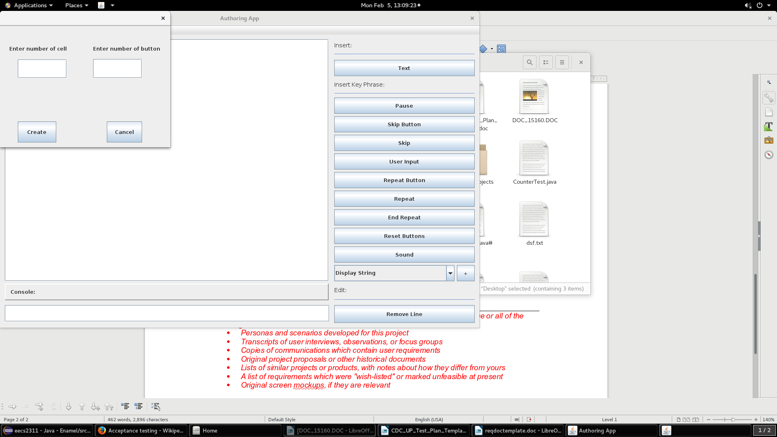

2. save:
Select File >Save As
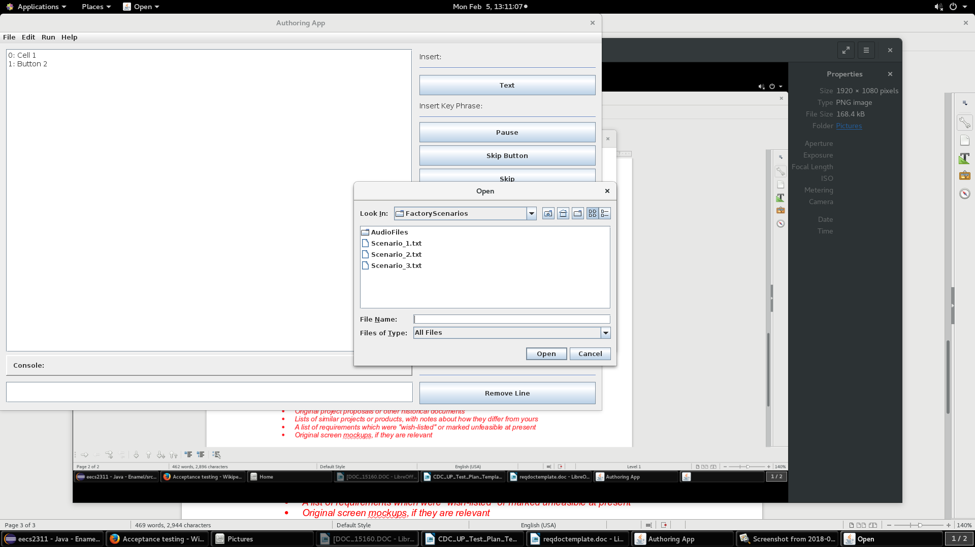
3. creating function:
write in console and press buttons on the left

4. Appendices
If you wish to append any documents, do so here. You may wish to include some or all of the following:
- Personas and scenarios developed for this project
- Transcripts of user interviews, observations, or focus groups
- Copies of communications which contain user requirements
- Original project proposals or other historical documents
- Lists of similar projects or products, with notes about how they differ from yours
- A list of requirements which were "wish-listed" or marked unfeasible at present
- Original screen mockups, if they are relevant

5. References
List references and source documents, if any, in this section.

6. Index
If your document is very large, consider compiling an index to help readers find specific items.

